Experiment worksheet

1.1 Scientists review the research of other scientists

Pages 2–3 and 180

Experiment 1.1: Extracting DNA

Aim

To extract a sample of DNA from peas.

Materials

PART A

• 100 g (½ cup) dried peas soaked overnight in 2 cups of water, or frozen peas (thaw first)

• 200 mL (1 cup) water

• 6 g (1 tsp) table salt

• 20 mL dishwashing liquid

• 1 g (¼ tsp) meat tenderiser

• Blender

• 1 L beaker

• Sieve

• Stirring rod or spoon

• Timer

PART B

• Ice-cold ethanol (stand a sealed bottle containing 200 mL ethanol in a metal bowl of ice water for an hour prior to using)

• Methylene blue stain

• Test tubes and test-tube rack or 50 mL glass vials

• Skewer, glass stirring rod (toothpick for vials)

• Microscope

• Clean microscope slides and cover slips

CAUTION: ETHANOL IS FLAMMABLE.

Method

PART A

1 Dissolve the salt in the water.

2 Combine the peas and salty water in a blender. Mix for 15 seconds to form a lumpy liquid in which the peas are only just broken up. Do not overblend the mixture.

3 Pour the contents through a sieve into the 1 L beaker. Discard the pulp in the sieve.

4 Add the dishwashing liquid and stir the mixture gently to avoid making bubbles. Stir for 8 minutes.

5 Add the meat tenderiser and continue to stir gently for another 2 minutes.

6 This is your prepared DNA source.

PART B

1 Pour 15 mL of the DNA source into a test tube or a 50 mL glass vial. There should be enough of this mix for eight test tubes or vials, which can be shared in the class.

2 Dribble 15 mL ice-cold ethanol down the side of the test tube or vial – there should be equal amounts of filtrate and ethanol in the test tube or vial.

3 Leave the test tube or vial to separate into layers. This will take at least 10 minutes. The alcohol will eventually settle on top of the watery pea mixture. DNA is less dense than water and should float up into the alcohol layer, leaving the other cellular components behind.

4 When the mixture has separated completely, use a stirring rod to gently twirl and twist the DNA to collect it from the alcohol layer (Figure 1). DNA is white in colour.

5 Put a small amount of the DNA sample onto a glass slide. Gently spread the DNA mixture. Add 1 drop of methylene blue stain to the DNA mixture. Place the cover slip on the edge of the methylene blue and allow it to fall into place. This should eliminate any air bubbles.

6 Look at your sample under ×10 magnification. Once you have focused the microscope, you can then try the higher magnifications using the fine focus knob to focus. You will not see the double helix strands, but you should see clumps of DNA material that may look like a tangled mass of strands.

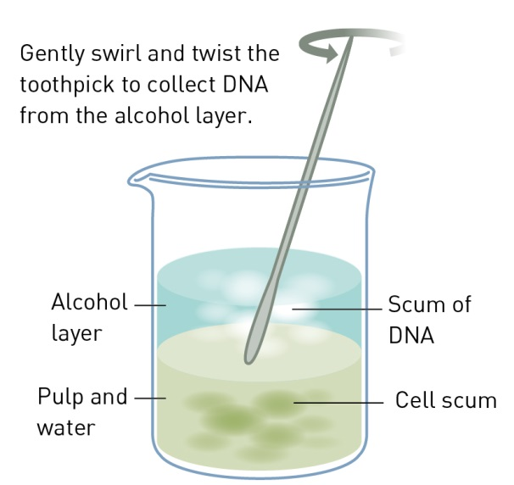

Figure 1Procedure for collecting DNA from the alcohol layer.

Results

Present your results as a labelled diagram, with several short statements or labels explaining your observations.

Discussion

1 Briefly describe the appearance of the DNA under the microscope. Why can you not see the double helix?

|  |
| --- |
|  |
|  |
|  |

2 Do you think human DNA will look the same as the DNA from dried peas?

|  |
| --- |
|  |
|  |
|  |

3 What role does each of the additives (dishwashing detergent, meat tenderiser and alcohol) play?

|  |
| --- |
|  |
|  |
|  |

4 What materials remain in the watery layer?

|  |
| --- |
|  |
|  |

Conclusion

Summarise the outcomes of this experiment.

|  |
| --- |
|  |
|  |
|  |

Experiment worksheet

1.2 DNA consists of a sugar-phosphate backbone and four complementary nitrogen bases

Pages 4–5 and 181

Challenge 1.2: Modelling the structure of DNA

Aim

To construct a model of DNA that shows the complementary bases arranged in a double helix.

What you need

• 4 long pipe cleaners (2 different colours)

• 24 beads (6 different colours)

What to do

1 Choose two pipe cleaners of the same colour.

2 On each pipe cleaner, thread beads of two alternating colours. Leave about 2 cm of space between each bead. This represents the sugar–phosphate backbone of DNA molecules (Figure 1).

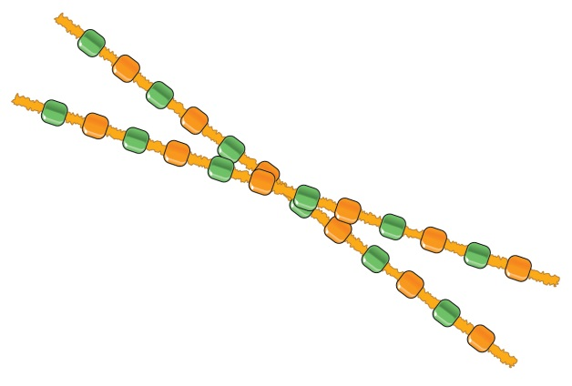

Figure 1

3 Cut the remaining two pipe cleaners into 5 cm segments. These will be used to create the paired nitrogen bases A-T and G-C.

4 Choose two colours to represent adenine and thymine. Thread these two beads on six of the cut pipe cleaner strands.

5 The remaining colours represent guanine and cytosine. Thread these two beads on the remaining cut pipecleaner strands (Figure 2).

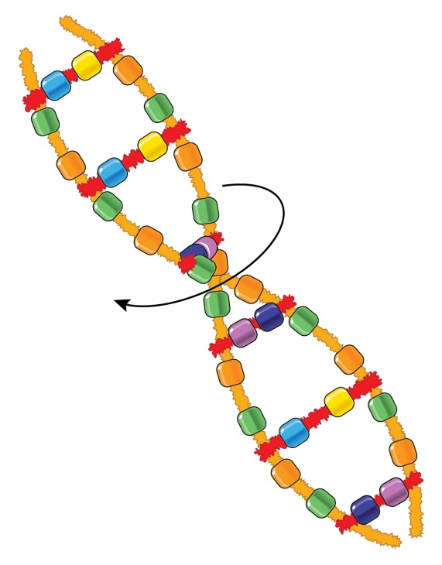

Figure 2

6 Attach the short segments of nitrogen bases onto the backbone of the DNA molecule. Make sure each nitrogen base strand is attached next to the same coloured bead (that represents the sugar in the sugar–phosphate backbone). You should have formed a ladder-like structure with the A-T and G-C nitrogen bases as the rungs of the ladder.

7 Twist your ladder so that it forms a double helix structure (Figure 3).

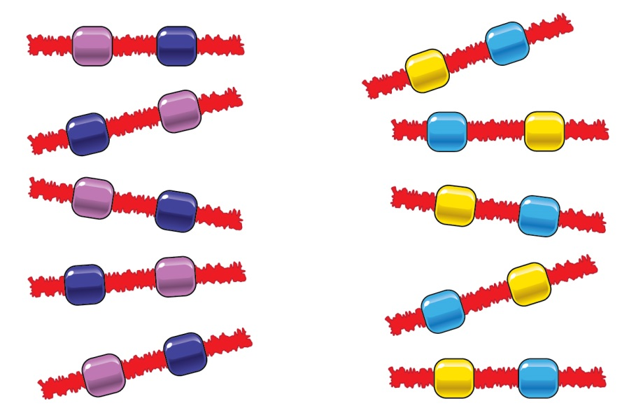

Figure 3

Discussion

1 What colour beads represented:

a adenine?

|  |
| --- |
|  |

b thymine?

|  |
| --- |
|  |

c guanine?

|  |
| --- |
|  |

d cytosine?

|  |
| --- |
|  |

2 What do the letters DNA stand for?

|  |
| --- |
|  |

3 Describe a ‘double helix’.

|  |
| --- |
|  |
|  |

4 Draw a single nucleotide from your model.

|  |
| --- |
|  |

Experiment worksheet

1.3 Chromosomes are DNA molecules carrying genetic information in the form of genes

Pages 6–9 and 182

Skills lab 1.3: Making protein

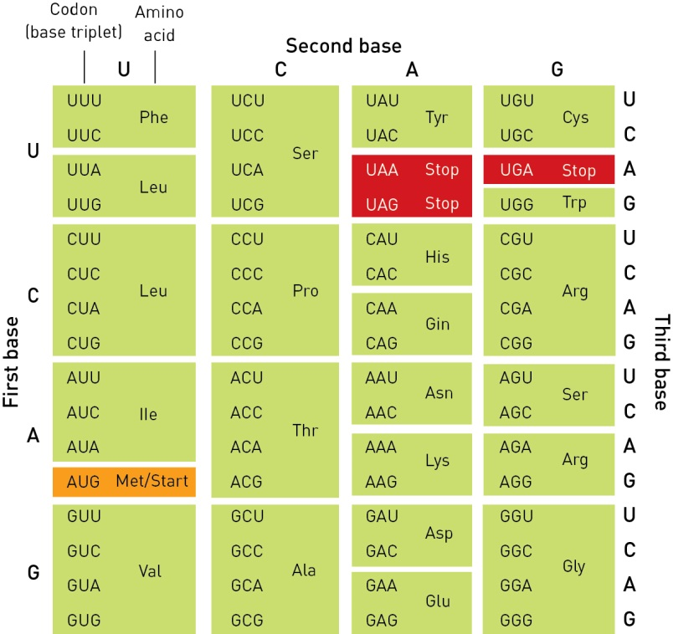

Figure 1 The entire genetic code was deciphered by 1966 and scientists now understand which amino acid is coded for by each codon. There are three stop codons and one start codon.

A section of a DNA sequence made from a particular gene is shown below:

T A C T T A G A G A T G C T G A C T

1 Write down the complementary sequence of DNA for this part of the gene.

|  |
| --- |
|  |

2 If the strand shown is the template strand of the gene, write the RNA sequence that would be made. (Remember to use uracil instead of thymine.)

|  |
| --- |
|  |

3 Break the strand into groups of three. Each group is called a codon. Using the genetic code in Figure 1, write down the amino acids that the above sequence codes.

|  |
| --- |
|  |

4 How would the protein strand change if the 12th nucleotide in the DNA template strand (guanine) was changed to a thymine?

|  |
| --- |
|  |
|  |
|  |

Experiment worksheet

1.4 Mitosis forms new somatic cells

Pages 10–11 and 183

Skills lab 1.4: Cell division in action

Aim

To identify cells undergoing different stages of mitosis.

What you need

• Prepared microscope slide/s showing a tissue that is in the process of growth and development

• Light microscope

Alternatively, you could prepare your own slides from the growing root tips of a plant, such as garlic or spring onion.

What to do

1 View a slide under the microscope at the greatest magnification possible.

2 In your field of view, identify the cells that are in interphase and those that are undergoing the other phases of mitosis.

3 Sketch at least four cells undergoing different stages of cell division. Remember the conventions for drawing biological images under the microscope. Clearly label all the components within the cell that you can identify correctly.

• DNA is visible under the microscope during interphase but not as individual chromosomes.

• What might be an advantage for DNA being tightly wound during mitosis?

|  |
| --- |
|  |

• Describe the possible consequences for a cell if errors occur during the process of DNA replication that occurs during interphase.

|  |
| --- |
|  |

• Explain the significance of mitosis for an organism.

|  |
| --- |
|  |
|  |
|  |

Experiment worksheet

1.5 Meiosis forms gamete cells

Pages 12–13 and 183

Challenge 1.5: Modelling meiosis

Aim

To model the stages of meiosis.

What you need

• Pipe cleaners

• Sticky tape

• Felt-tipped pens

• A4 sheet of paper

What to do

1 Draw the outer membrane of a cell on the sheet of paper.

2 Cut a pipe cleaner in half and place both halves in the centre of the cell. These represent two chromosomes in a cell starting meiosis.

3 Cut a second pipe cleaner in half and twist each half around the centre (centromere) of the first chromosomes.

4 Place the two chromosomes in the centre of your cell.

What phase does your cell represent?

5 Move each chromosome to opposite ends of your cell, keeping the twisted centromeres intact.

What phase does your cell represent?

6 Turn the paper over and draw two cells half the size of the original cell.

7 Place one chromosome in the centre of each cell.

• What phase do your cells represent?

8 Untwist the two pipe cleaners and move them to the opposite ends of each cell.

• What phase do your cells represent?

9 Draw a line down the centre of each cell.

• What phase do your cells represent?

10 Draw a picture of each stage that you demonstrated with the pipe cleaners.

Discussion

1 How many sets of chromosomes does a cell have before it undergoes meiosis?

|  |
| --- |
|  |

2 How many sets of chromosomes does a cell have after it undergoes meiosis?

|  |
| --- |
|  |

3 Why do gametes need to be haploid?

|  |
| --- |
|  |
|  |
|  |
|  |

Experiment worksheet

1.6 Alleles can produce dominant or recessive traits

Pages 14–15 and 184

Experiment 1.6: Zazzle genetics

Materials

• A bag containing 6 different coloured counters

• Permanent marker

• Toothpicks

• Pipe cleaners

• Pink and white large marshmallows

• Small marshmallows

• Blue and black felt-tipped pens

Method

1 Choose a counter from the bag. Use the permanent marker to draw an ‘A’ on one side and an ‘a’ on the other side. This represents the inheritance of a long antenna (A) or a short antenna (a) from the parent.

2 Flip the counter to determine which allele is passed on to your Zazzle from the father. Write your results in the table in the results section.

3 Use a second counter to represent two body segments (L) or one body segment (l). Flip the counter to determine which allele is passed on from the father. Write your result in the table.

4 Use three of the remaining counters to represent the following characteristics of the father and write your results in the table.

• Four eyes (E) or two eyes (e)

• Straight tail (T) or curly tail (t)

• One hump (H) or two humps (h)

5 Repeat steps 1–4 for the alleles passed from the mother to your Zazzle.

6 The final counter is used to determine the sex of your Zazzle. The mother has two X chromosomes. This means she can only pass on an X chromosome to your Zazzle baby. Draw an ‘X’’ on one side of the counter and a ‘Y’ on the other. Flip the counter to determine which chromosome is passed from the father to the child. You have now determined the sex of your Zazzle. A girl will have a pink marshmallow body. A boy will have a white marshmallow body.

7 Determine the phenotype of your Zazzle.

8 Use the materials to construct your Zazzle.

Results

Alleles inherited from the parent

|  |  |  |  |  |
| --- | --- | --- | --- | --- |
| Chromosome | Trait and letter representing it | Allele donated by father | Allele donated by the mother | Phenotype of baby Zazzle |
| 1 | Antenna (A or a) |  |  |  |
| 2 | Body length (L or l) |  |  |  |
| 3 | Eyes (E or e) |  |  |  |
| 4 | Tail (T or t) |  |  |  |
| 5 | Hump (H or h) |  |  |  |
| 6 | Sex (X or Y) |  | X |  |

Discussion

1 How many chromosomes were present in each of the:

a mother’s somatic cells?

|  |
| --- |
|  |

b father’s gametes?

|  |
| --- |
|  |

c baby Zazzle cells?

|  |
| --- |
|  |

2 Write down your baby Zazzle’s genotype for each trait.

|  |
| --- |
|  |
|  |

3 Why does the baby Zazzle have two alleles for each trait?

|  |
| --- |
|  |
|  |
|  |

4 Draw a diagram of your baby Zazzle.

|  |
| --- |
|  |

Conclusion

Describe how dominant and recessive traits are inherited.

|  |
| --- |
|  |
|  |
|  |
|  |

Experiment worksheet

1.7 Alleles for blood group traits co-dominate

Pages 16–17 and 185

Experiment 1.7: Blood typing experiment

Aim

To determine the inheritance of blood groups.

Materials

• Anti-A solution (2 M hydrochloric acid solution)

• Anti-B solution (2 M sulfuric acid solution)

• Sample blood O (distilled water)

• Sample blood A (0.1 M silver nitrate solution)

• Sample blood B (0.1 M barium nitrate solution)

• Sample blood AB (a 50:50 mix of 0.1 M silver nitrate and 0.1 M barium nitrate solution)

• Spotting tiles

• 6 pipettes, one for each solution

Method

1 Place two drops of sample blood O in the first wells of the first two rows of your spotting tile (Figure 1).

2 Using a fresh pipette, place two drops of sample blood A in the second wells of your spotting tile.

3 Repeat for the remaining blood samples.

4 Add a drop of anti-A solution to each of the wells in the first row of your tile.

5 Add a drop of anti-B solution to each of the wells in the second row of your tile.

6 Record your observations in the table in the results section.

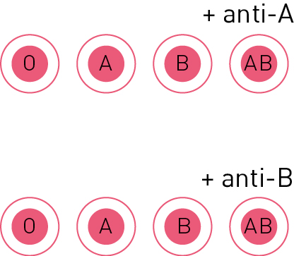

Figure 1 Spotting tile.

Results

|  |  |  |  |  |
| --- | --- | --- | --- | --- |
|  | Sample blood O | Sample blood A | Sample blood B | Sample blood AB |
| Anti-A |  |  |  |  |
| Anti-B |  |  |  |  |

Discussion

1 What possible genotype/s could the following people have?

a Person with blood group A

|  |
| --- |
|  |

b Person with blood group B

|  |
| --- |
|  |

c Person with blood group AB

|  |
| --- |
|  |

d Person with blood group O

|  |
| --- |
|  |

2 Could a person with blood group AB have a child with blood type O? Explain your answer.

|  |
| --- |
|  |
|  |
|  |

3 A child with blood group O claimed that she was adopted because her mother had blood group A and father had blood group B. How would you explain that this is still possible?

|  |
| --- |
|  |
|  |
|  |

Conclusion

How is blood grouping inherited?

|  |
| --- |
|  |
|  |
|  |
|  |
|  |

Experiment worksheet

1.8 Alleles on the sex chromosomes produce sex-linked traits

Pages 18–21 and 186

Experiment 1.8: Colour-blindness inheritance

Aim

To examine the inheritance of X-linked traits.

Materials

• 2 counters

• Permanent marker

Li is colour blind (XbY) and would like to start a family with Maria. Maria is not colour blind but knows that she is heterozygous (XBXb) for the trait as her father is colour blind.

Method

1 On one counter, write Xb on one side and Y on the other.

2 On the second counter, write Xb on one side and XB on the other.

3 Toss the counters eight times and record the possible genotypes of Li’s and Maria’s children.

Results

|  |  |
| --- | --- |
| Coin toss | Genotype of child |
| 1 |  |
| 2 |  |
| 3 |  |
| 4 |  |
| 5 |  |
| 6 |  |
| 7 |  |
| 8 |  |

Discussion

1 How many girls and boys did Li and Maria have?

|  |
| --- |
|  |

2 How many children were colour blind? How many had normal vision?

|  |
| --- |
|  |

3 Was colour blindness more common in boys or girls?

4 Can non-colour-blind parents have a colour-blind son? Use a Punnet square to support your answer.

|  |
| --- |
|  |

5 Can a non-colour-blind daughter have a colour-blind father? Use a Punnet square to support your answer.

|  |
| --- |
|  |

6 Can two colour-blind parents have a non-colour-blind son? Use a Punnet square to support your answer.

|  |
| --- |
|  |

Conclusion

How is colour blindness inherited?

|  |
| --- |
|  |
|  |
|  |
|  |
|  |
|  |

Experiment worksheet

1.10 Mutations are changes in the DNA sequence

Pages 26–29 and 187

Skills lab 1.10: Identifying mutations

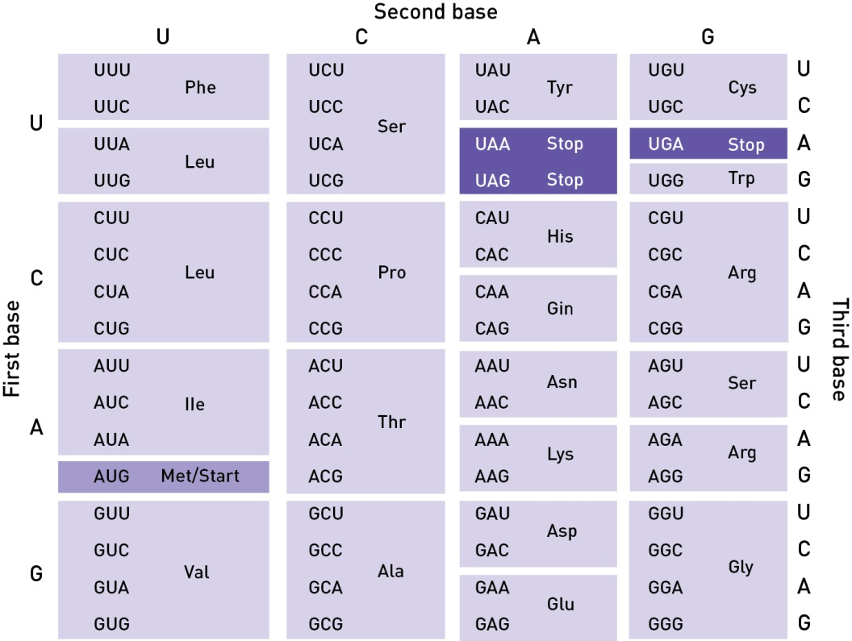

**Figure 1** The genetic code.

1 A normal RNA sequence is shown below, together with two different genetic mutations.

• Normal AUG ACG CAG AAU UGG GAU CCU ACG

• Mutation 1 AUG ACA CAG AAU UGG GAU CCU ACG

• Mutation 2 AUG AGC AGA AUU GGG AUC CUA CG

a Name the type of mutation represented in each case. Explain your answer.

|  |
| --- |
|  |
|  |

b Describe the outcome of mutation 1 on protein synthesis. You may wish to consult the genetic code in Figure 1.

|  |
| --- |
|  |
|  |

c Describe the outcome of mutation 2 on protein synthesis.

|  |
| --- |
|  |
|  |
|  |

2 Genetic Creutzfeldt–Jacob disease (CJD) is caused by an abnormal protein called PrPc. This protein is formed because of a mutation in the PrPc gene on chromosome 20 and occurs in DNA base triplet 200 in the gene’s sequence.

|  |  |  |  |
| --- | --- | --- | --- |
| DNA base triplet number | 199 | 200 | 201 |
| Normal gene | TGG | CTC | CAA |
| Mutated gene | TGG | TTC | CAA |

a What type of mutation is this?

|  |
| --- |
|  |

b Describe the amino acid change that would occur in the PrPc protein.

|  |
| --- |
|  |
|  |
|  |

c Distinguish between natural and induced mutation.

|  |
| --- |
|  |
|  |
|  |
|  |
|  |

Experiment worksheet

1.13 Genetic engineering is used in medicine

Pages 34–35 and 188

Challenge 1.13: Edible genetic engineering

Aim

To model how insulin is genetically engineered.

What you need

• 1 packet of lolly snakes

• 1 packet of sour worm lollies

What to do

1 Carefully remove a small amount from the end of one lolly snake and stick the ends together so they form a loop. You have formed a plasmid of DNA.

2 Obtain one sour worm. This is your insulin gene. Carefully remove a small amount of the ends of your insulin gene and insert it into your plasmid to form a larger circle. You have created a recombinant plasmid with DNA from different organisms.

3 Draw a picture of your plasmid. Label the plasmid and the introduced gene.

4 Describe how you could clone your insulin plasmid in a bacterial cell.

Discussion

1 What is a plasmid?

|  |
| --- |
|  |

2 Why is insulin needed by some members of the community?

|  |
| --- |
|  |
|  |
|  |

3 Before genetic engineering was possible, pig insulin was often used. Why would genetically engineered human insulin be preferable? (Consider the way the immune system would respond to pig insulin.)

|  |
| --- |
|  |
|  |
|  |